GO Math! Grade 1 Chapter Test Alignment

This assessment guidance is designed as a companion to the Go Math K-5 Guidance Documents. It provides support for modifying GO Math! Chapter Tests to align to the changes recommended in the Guidance Documents. The changes include rationale, often guided by the Rule of Thumb for Assessments, provided in Part 2 of the Guidance documents:

- Eliminate any questions aligned to lessons/content that have been deleted.
- Add vetted questions aligned to lessons that have been added.
- Remove any directions in questions that require a specific strategy or model. Note: This is the only modification we will be making to questions.

In addition, the aspect(s) of rigor targeted by the standards for the chapter has been identified. Some changes to questions are based on alignment to the appropriate aspect of rigor.

Chapter 1
Based on the standards addressed in the chapter, this assessment should address the following aspects of rigor:
✓Procedural Skill/Fluency
Conceptual Understanding
✓Application

Grade 1 / Chapter 1: Addition Concepts
Problem # | Action (Keep/Modify/Delete) | Details for the Action | Rationale
1 | Modify | Remove pictures. | Assessment Rule of Thumb: Question requires a specific model.
2 | Modify | Remove pictures. Say/Write- “There are 4 worms and 2 more worms. Use pictures, words, or numbers to show how many worms.” | Assessment Rule of Thumb: Question requires a specific strategy.
3 | Keep
4 | Delete |  | Guidance document: Lesson deleted
5 | Keep
6 | Modify | Delete all text.  Add “solve.” | Aspects of Rigor: The tagged standard (1.OA.A.1) requires Application, but giving the equations makes this a procedural skill problem. Therefore, the revised item should be re-tagged as 1.OA.C.6
7 | Modify | Delete all text.  Add “solve.”
8 | Keep
9 | Keep
10 | Modify | Delete bar model. | Assessment Rule of Thumb: Question requires a specific model.
11 | Keep
12 | Keep

Chapter 2
Based on the standards addressed in the chapter, this assessment should address the following aspects of rigor:
✓Procedural Skill/Fluency
✓Conceptual Understanding
✓Application

Grade 1 / Chapter 2: Subtraction Concepts
Problem # | Action (Keep/Modify/Delete) | Details for the Action | Rationale
1 | Modify | Remove first two sentences. Replace with “There are 8 bugs. 3 walk away. Write how many there are now.” | Assessment Rule of Thumb: Question requires a specific strategy.
2 | Modify | Remove “Circle the part you take away from the group. Then cross it out.” Remove diagram  Replace with “There are 5 bees. 3 bees fly away. Write how many bees are left.” | Assessment Rule of Thumb: Question requires a specific strategy.
3 | Modify | Remove “Circle the part you take away from the group. Then cross it out.” Replace with “There are 4 flies. 2 flies fly away. Write how many flies are left.” | Assessment Rule of Thumb: Question requires a specific strategy.
4 | Keep
5 | Modify | Delete the first sentence of the item and the diagram. | Assessment Rule of Thumb: Question requires a specific strategy.
6 | Modify | Delete first paragraph of directions and bar model. | Assessment Rule of Thumb: Question requires a specific strategy.
7 | Keep | Question aligns to 1.OA.A.1
8 | Modify | Remove bar model and first paragraph of directions. | Assessment Rule of Thumb: Question requires a specific strategy.
9 | Delete |  | Aspects of Rigor: The standard targets conceptual understanding, but this is an application question
10 | Keep
11 | Modify | Remove first two sentences of stem. | Assessment Rule of Thumb: Question requires a specific strategy.
12 | Keep

Questions to be added:
Added Lesson | Source | Question
Replace #9 | EngageNY, Grade 1, Module 1, End of Module Assessment: #1 | 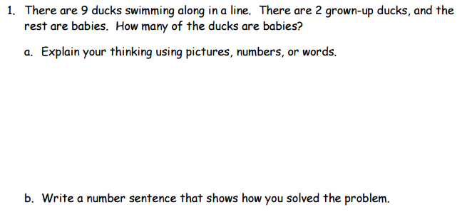

Chapter 3
Based on the standards addressed in the chapter, this assessment should address the following aspects of rigor:
✓Procedural Skill/Fluency
✓Conceptual Understanding
✓Application

Grade 1 / Chapter 3: Addition Strategies

Note: On this test, questions that require a specific strategy or model have been deleted or modified in order to get evidence of the standards. However, students should still be encouraged to use representations to help them, as needed.
Problem # | Action (Keep/Modify/Delete) | Details for the Action | Rationale
1 | Delete
2 | Keep
3 | Delete |  | Guidance document: Lesson deleted
4 | Delete |  | Guidance document: Lesson deleted
5 | Delete |  | Guidance document: Lesson deleted
6 | Delete |  | Assessment Rule of Thumb: Question requires a specific strategy.
7 | Keep
8 | Delete |  | Assessment Rule of Thumb: Question requires a specific strategy.
9 | Delete |  | Assessment Rule of Thumb: Question requires a specific strategy.
10 | Modify | Keep first sentence and delete the rest of the text. Add in “Write an addition sentence to show the sum.”  Delete the equations with the boxes. | Assessment Rule of Thumb: Question requires a specific model.
11 | Delete
12 | Modify | Delete “Draw a picture of the apples.” | Assessment Rule of Thumb: Question requires a specific strategy.

Questions to be added:
Added Lesson | Source | Question
3.9.2; and replacing several questions that required a specific strategy | EngageNY, Grade 1, Module 1, End of Module Assessment: #4 | 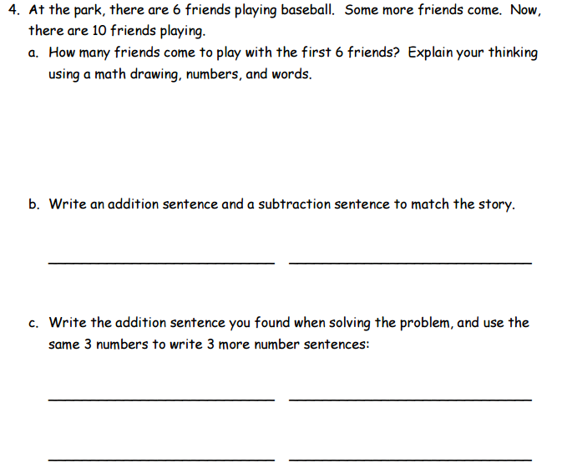
 | Adapted from EngageNY, Grade 1, Module 1, Mid Module Assessment: #3 | Look at the party picture!  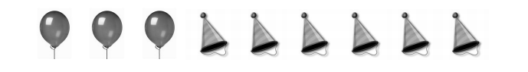  Write at least two addition sentences using 3, 6 and 9 that describe the party picture.  _______________ _______________
 | EngageNY, Grade 1, Module 1, Mid Module Assessment: #2 | 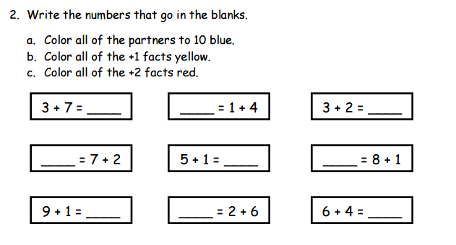

Chapter 4
Based on the standards addressed in the chapter, this assessment should address the following aspects of rigor:
✓Procedural Skill/Fluency
Conceptual Understanding
✓Application

Grade 1 / Chapter 4: Subtraction Strategies

Note: On this test, questions that require a specific strategy or model have been deleted or modified in order to get evidence of the standards. However, students should still be encouraged to use representations to help them, as needed.
Problem # | Action (Keep/Modify/Delete) | Details for the Action | Rationale
1 | Keep
2 | Keep
3 | Keep
4 | Modify | Delete first two sentences and the ten frames. | Assessment Rule of Thumb: Question requires a specific strategy.
5 | Delete |  | Assessment Rule of Thumb: Question requires a specific model.
6 | Keep
7 | Keep
8 | Keep
9 | Modify | Delete sentence and model. | Assessment Rule of Thumb: Question requires a specific strategy.
10 | Delete |  | Assessment Rule of Thumb: Question requires a specific strategy.
11 | Modify | Delete sentence “Draw a picture to help you subtract.”  Delete second part of the item. | Assessment Rule of Thumb: Question requires a specific strategy.

Questions to be added:
Added Lesson | Source | Question
 | Adapted from EngageNY, Grade 1, Module 1, Topic G, Lesson 26 Problem Set: #5 & #6 | Solve.  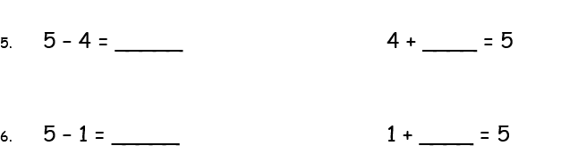  Note: The directions have been removed from this question based on the Assessment Rule of Thumb: Question requires specific strategy.

Chapter 5
Based on the standards addressed in the chapter, this assessment should address the following aspects of rigor:
✓Procedural Skill/Fluency
✓Conceptual Understanding
✓Application

Grade 1 / Chapter 5: Addition and Subtraction Relationships
Problem # | Action (Keep/Modify/Delete) | Details for the Action | Rationale
1 | Modify | Delete bar model diagram. | Assessment Rule of Thumb: Question requires a specific model.
2 | Keep
3 | Keep
4 | Keep
5 | Modify | Delete all text and picture of cubes. Add “Write the numbers that make the number sentence true.” | Assessment Rule of Thumb: Question requires a specific model.
6 | Keep
7 | Keep | Delete “draw a picture” from the last sentence. | Assessment Rule of Thumb: Question requires a specific strategy.
8 | Keep
9 | Keep
10 | Keep
11 | Keep
12 | Modify | Delete bar model diagram. | Assessment Rule of Thumb: Question requires a specific model.

Questions to be added:
Added Lesson | Source | Question
5.7.1 | Illustrative Mathematics 1.OA Maria’s Marbles

Chapter 6
Based on the standards addressed in the chapter, this assessment should address the following aspects of rigor:
✓Procedural Skill/Fluency
✓Conceptual Understanding
Application

Grade 1 / Chapter 6: Count and Model Numbers
Problem # | Action (Keep/Modify/Delete) | Details for the Action | Rationale
1 | Keep
2 | Keep
3 | Delete |  | Guidance document: Lesson deleted
4 | Keep
5 | Keep
6 | Keep
7 | Keep
8 | Keep
9 | Keep
10 | Delete |  | Not aligned to standard, 1.NBT.A only requires students to work with 2-digit numbers.
11 | Keep
12 | Keep

Questions to be added:
Added Lesson | Source | Question
 | EngageNY, Grade 1, Module 4, Mid Module Assessment: #4 | 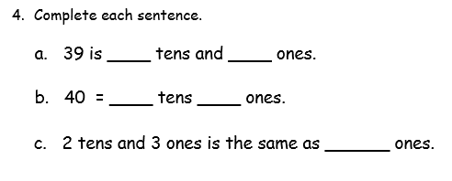  Note: 1.NBT.B.2

Chapter 7
Based on the standards addressed in the chapter, this assessment should address the following aspects of rigor:
Procedural Skill/Fluency
✓Conceptual Understanding
Application

Grade 1 / Chapter 7: Compare Numbers
Problem # | Action (Keep/Modify/Delete) | Details for the Action | Rationale
1 | Keep
2 | Keep
3 | Keep
4 | Keep
5 | Keep
6 | Keep
7 | Keep
8 | Keep
9 | Keep
10 | Keep
11 | Keep
12 | Keep

Chapter 8
Based on the standards addressed in the chapter, this assessment should address the following aspects of rigor:
✓ Procedural Skill/Fluency
Conceptual Understanding
Application

Grade 1 / Chapter 8: Two Digit Addition and Subtraction
Problem # | Action (Keep/Modify/Delete) | Details for the Action | Rationale
1 | Delete |  | Guidance document: Lesson deleted
2 | Keep
3 | Keep
4 | Modify | Delete hundred chart and directions referring to the hundred chart. | Assessment Rule of thumb: Question requires a specific strategy.
5 | Modify | Delete text and picture. Directions should say “Add.” | Assessment Rule of thumb: Question requires a specific strategy.
6 | Modify | Delete text and picture. Directions should say “Add.” | Assessment Rule of thumb: Question requires a specific strategy.
7 | Keep
8 | Delete |  | Guidance document: Lesson deleted
9 | Keep
10 | Modify | Add “14+23=__” | Aspects of Rigor: The standard targets conceptual understanding, but this is an application question.
11 | Delete |  | Not aligned to 1.NBT.C.4
12 | Keep

Chapter 9
Based on the standards addressed in the chapter, this assessment should address the following aspects of rigor:
✓ Procedural Skill/Fluency
Conceptual Understanding
Application

Grade 1 / Chapter 9: Measurement
Problem # | Action (Keep/Modify/Delete) | Details for the Action | Rationale
1 | Keep
2 | Keep
3 | Keep
4 | Keep
5 | Keep
6 | Keep
7 | Keep
8 | Keep
9 | Keep
10 | Keep
11 | Keep

Chapter 10
Based on the standards addressed in the chapter, this assessment should address the following aspects of rigor:
Procedural Skill/Fluency
Conceptual Understanding
✓ Application

Grade 1 / Chapter 10: Represent Data
Problem # | Action (Keep/Modify/Delete) | Details for the Action | Rationale
1 | Keep
2 | Keep
3 | Keep
4 | Keep
5 | Keep
6 | Keep
7 | Keep
8 | Keep
9 | Keep
10 | Keep
11 | Keep
12 | Keep

Chapter 11
Based on the standards addressed in the chapter, this assessment should address the following aspects of rigor:
Procedural Skill/Fluency
Conceptual Understanding
✓ Application

Grade 1 / Chapter 11: Three Dimensional Geometry
Problem # | Action (Keep/Modify/Delete) | Details for the Action | Rationale
1 | Keep
2 | Keep
3 | Keep
4 | Keep
5 | Keep
6 | Keep
7 | Keep
8 | Keep
9 | Keep
10 | Keep

Chapter 12
Based on the standards addressed in the chapter, this assessment should address the following aspects of rigor:
Procedural Skill/Fluency
Conceptual Understanding
✓ Application

Grade 1 / Chapter 12: Two Dimensional Geometry
Problem # | Action (Keep/Modify/Delete) | Details for the Action | Rationale
1 | Keep
2 | Keep
3 | Keep
4 | Keep
5. | Keep
6 | Keep
7 | Delete |  | Guidance document: Lesson deleted
8 | Keep
9 | Keep
10 | Keep

